Conversational Armenian
History
12th Week

Ani – The historic Armenian capital

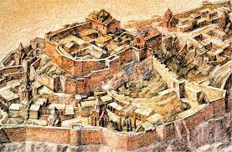
The earliest records about Ani date back to the early Middle Ages, the 5th century, as one of the fortresses of the Kamsarakan rulers.
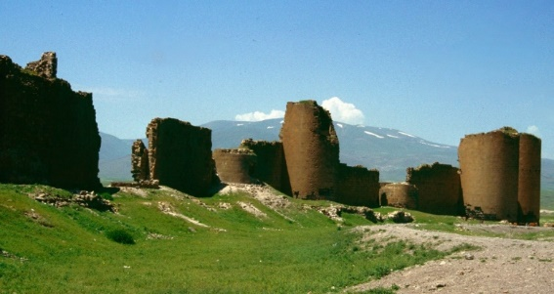
• At the beginning of the 9th century, the Armenian prince Ashot (790-826) bought the province of Shirak with the fortress of Ani from the Kamsarakan family.

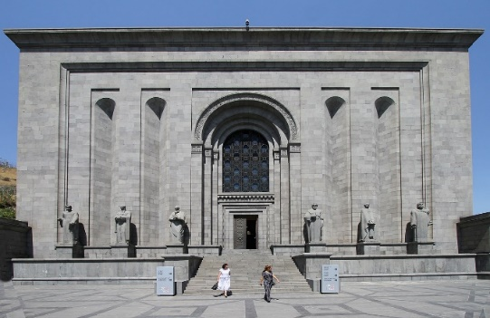
• In 961, King Ashot III moved the capital from Kars to Ani, which enjoyed a more inaccessible location; the city was on the banks of the Akuryan River, at the crossroads of trade routes.

• About 10 years later, in 971, Ashot III built the walls of Ani, which his son Sembat II (978-990) expanded, building the Sembatashen walls in just one year. The walls were 25-35 feet high, and 8200 feet long.
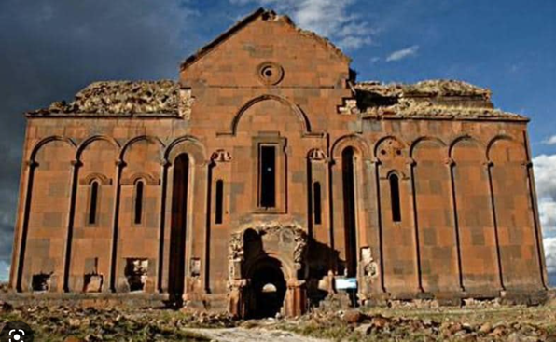
• During King Sembat II's reign, the Armenian Catholicos (the spiritual leader) residence moved from Argina village to Ani. In Ani, architect Trdat (Terdatus) built the famous Cathedral of Ani which became the main cathedral and the residence of the Catholicos.

When Armenian Architect Mark Grigoryan (1900-1978) was working on constructing Matenadaran (the museum and institute of old manuscripts), he used the architectural style and architectural solutions of Ani’s main Cathedral.

Cilicia
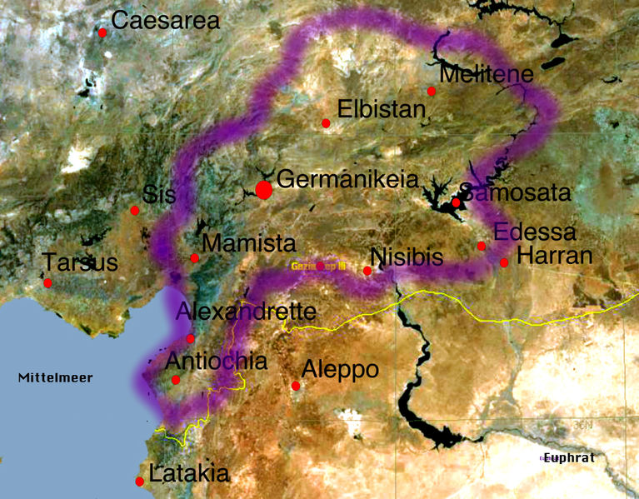
After the Armenian Kingdom of Ani collapsed in 1045, the Armenian principalities of Artsakh (Nagorno-Karabakh), Tashir, and Van-Vaspuragan maintained their certain degree of freedom (autonomy) for some time. However, the situation in Armenia was becoming unstable and unsafe. On top of that, the Byzantine Empire was trying to relocate the Armenian nobility from Armenia itself to the area known as Cilicia, near the Mediterranean Sea. By doing so, the Byzantine emperors were pursuing two-fold goals: on the one hand to weaken Armenia itself; on the other hand, to strengthen the Christian presence near the Mediterranean Sea, to counter the emerging Islamic threat coming from North Africa and the Middle East. As a result, many Christian-Armenian rulers settled in Cilicia and purchased or built new fortresses.
The geographical area of Cilicia has been under Armenian control for about ten centuries before that, during the reign of Tigran the Great (95-55) Armenian king.

The first Armenian principality of Cilicia emerged in 1071 under the Armenian commander Pilatros. The capital of his principality was Marash. Coming from the Armenian princes of Kamsarakan, Vasil established another Armenian principality. However, the most successful and enduring was the principality that came into existence under Rouben’s rule.

Ruben was the head of the security service of the last king of the Bagratuni Kingdom of Armenia, Gagik II. Rouben engaged in battles to strengthen his power. He proclaimed himself Prince Rouben I (1075-1080), making the fortress of Tarsus the capital of his principality.
His son Constantine (1080-1085) conquered the Mountainous parts of Cilicia from the Byzantium and Seljuk-Turks, and rebuilt the fortress of Vahka, which became the new center of Cilicia. Constantine's son Toros joined with Vasil, defeated the Turks near the city of Berdus, and successfully pushed back the attacks of the Byzantines.
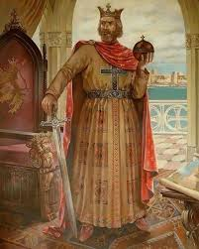
The city of Sis, which later became the capital, was added to the principality. Levon, the son of Thoros, went out to the coastal regions of Cilicia and captured the famous city of Adana. However, in 1137, the Emperor of Byzantium invaded Cilicia with a large army and, after a series of tough battles, captured both Levon and his sons Ruben and Toros. Eight years later, Thoros, escaping from captivity, declared himself the prince of Cilicia and began the reconquest of Cilicia. He reconquered the lost settlements in a matter of 5-6 years։
In the fall of 1151, the Byzantine empire attacked the Armenian principality of Cilicia. Toros, the Armenian ruler, was surrounded in the fortress of Mamestia. However, on a rainy day, he unexpectedly came out from the fort with his soldiers and defeated the enemy.
The Armenian Cilicia reached the height of its power during Rouben III's (1145-1187) and his brother Levons (Leo) II’s (1187-1219) rule. Rouben scored several victories against the Byzantines. In 1185, the Duke of Antioch invited Rouben to his Duchy, arrested him, and attacked the Armenian Cilicia. Levon, the brother Rouben, attacked and defeated Antioch's duke. After returning to Cilicia, Rouben willingly gave up the throne to his brother.

In 1187, Levon (Leo) became the ruler of Cilicia.
In May 1190, the king of Germany, Friedrich Barbarossa, arrived in Cilicia, planning to move to Jerusalem to liberate the tomb of Christ (Third Crusade). Leo the Great agreed to help him on the condition that the German ruler would recognize Cilicia as an independent kingdom. Emperor Frederick decided, but on June 10, 1190, he drowned not far from the historic city of Seleucia while bathing in a river or possibly crossing the river on horseback (no definitive information).
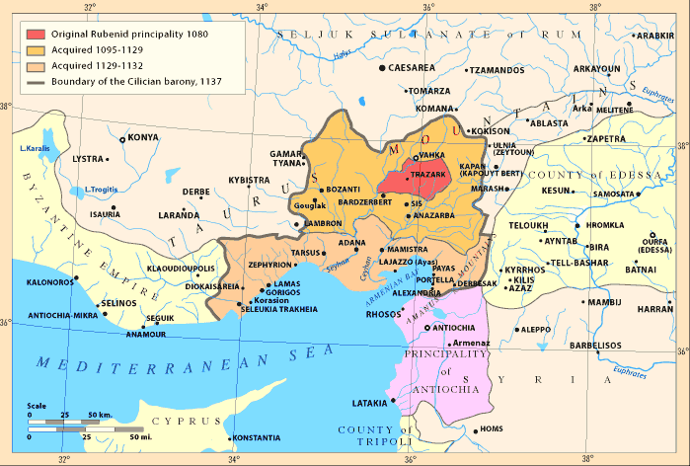
In 1196, the new king of Germany, Henry IV, and then the emperor of Byzantium, Alexios, agreed to recognize Levon as the governor of the independent Armenian state of Cilicia. On January 6, 1198, Levon was anointed king of the Armenian kingdom of Cilicia in Tarson, Cilicia.

Assignments
- What happened after the fall of Bagratun Armenia?
- What were the first Armenian authorities of Cilicia?
- What do we know about the temporary decline of the principality of Cilicia in the 12th century and the attempts to regain power years later?
- How and when did Cilicia's hundred-year struggle against Byzantium end?
- How did Cilicia become a kingdom from Armenian rule?
- Why do you think Levon was proclaimed king on January 6?

