Conversational Armenian. History
7th Week
The Summary of the previous lesson: We learnt the following:
- Tigran the Great was succeeded by his son, King Artavazd.
- The Roman Empire and Parthia were the main enemies of Armenia.
- Antonius, the general of Rome, invited Artavazd to negotiate, however, he arrested and killed him.
- The Romans conspired to kill Artaxerxes II (Artashes II), who succeeded Artavazd.
- After Artaxerxes II (Artashes), the Artashesian kingdom weakened and fell under the rule of Rome.

The Arshakuni Dynasty
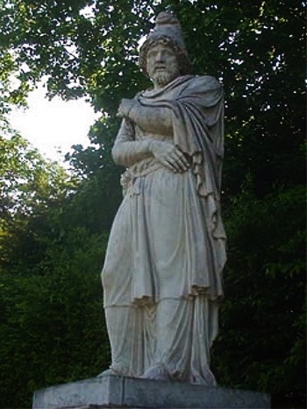
In year 1 AD, the Artashesian or Artaxid dynasty came to its end. Armenia no longer had a king; the country was ruled by governors appointed by Rome. However, the Armenian people did not tolerate the rulers appointed by Rome and did not want to submit to them.

When Vagharsh Arshakuni (Arsacid) came to power in Parthian Empire (Persia), the Armenian nobles came into agreement with him that his brother Tiridat (Tirdatus) Arshakuni should become the king of Great Armenia instead of the henchmen of Rome. Rome did not like that and sent an army to Armenia to overthrow Tiridat.

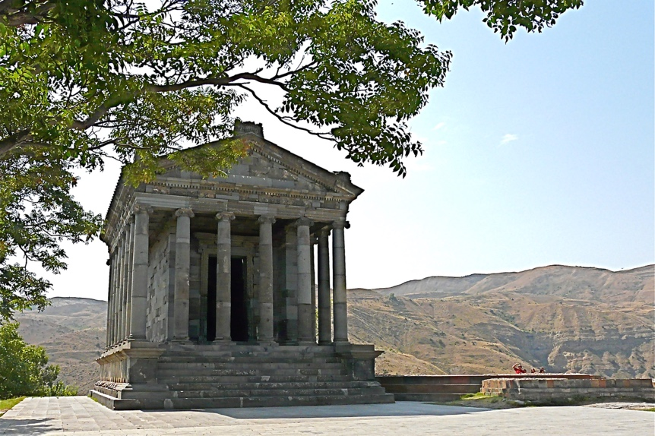
Armenia, and the Parthian kingdom came out victorious in the war that lasted for about 10 years. The Roman emperor Nero invited Tiridat to Rome to receive the crown and be recognized as king by Rome. Tiridat left for Rome with an army of 3,000, where Nero officially recognizes him as Tiridat the First, the king of Great Armenia. Nero also gave money and craftsmen to Armenia as a war-penalty to rebuild Artashat, which had suffered during the wars.

With Tiridat Arshakuni becoming the king of Armenia, the Arshakuni dynasty was established in our country. Peace prevailed in the kingdom and a period of development began. Not far from the capital, a mighty fortress of Garni was built. It had a beautiful heated royal bath. The temple of Garni and the remaining bath are still available to visitors. The pagan temple of Garni was built in 77 AD, three years before the Roman Coliseum was built. The temple is believed to have been dedicated to the sun God of Sun Helios-Mihir, who, was the symbol of light and truth.
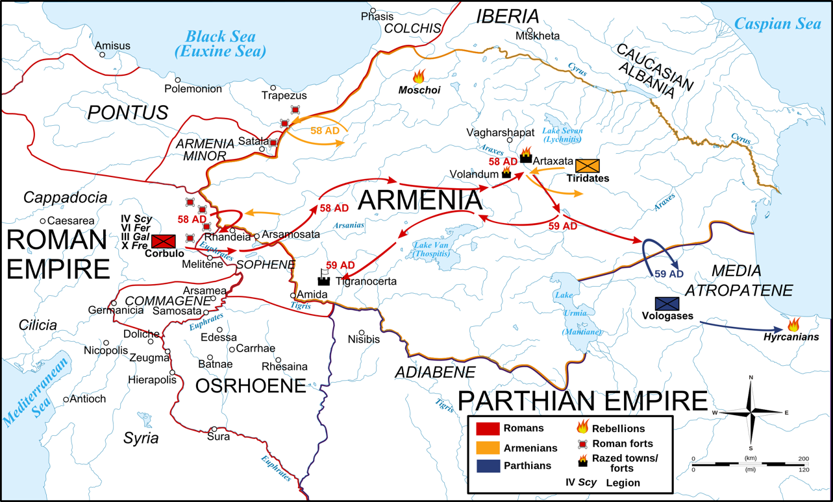

Questions and Assignments

- When did the Ardashesian dynasty come to end and who ruled Armenia after?
- Who was Vagharsh Arshakuni?
- How did Rome react to the decision to make Tiridat the new king of Armenia?
- Which Roman Emperor recognized Tiridat as the King of Armenia? Where did it happen?
- What happened after then Tiridat became Armenia’s king?
- Which fortress and temple were built in Armenia in 77AD?

